# **GENERAL INFO**

* *Course: 313CCS-5*
* *Assignment no: 2*
* *Marks: 4 marks*
* *Due Date on 21-May-2023*
* *Submit on Blackboard 1 pdf file.*
* *For extra credit, the game should be uncommon, and algorithms should be well written*
* *For issues, email me immediately.*
* ***Important Note!*** 
  + *You are not allowed to use any external sources without citation, including any AI-assisted tools.*
  + *Your answer must show and reflect your effort and views.*

Find or **invent a board game notion that involves challenges and more than one player.** Then, answer the following questions.

1. **What is the name of your game (if it does not, make one)?**

**8 ball pool**

1. **Sketch or draw the game idea and the board if available.**

The game simulates the game of billiards in the real world, as it brings together players from all over the world in one screen for the challenge.

Each table within a game consists of two players, each player is an opponent to the other. Each player has a type of ball that must be entered by the white ball. The goal is to enter his balls first, who will win this game.

The game consists of two types of games, the main game and the secondary game, and each of them has its own rules and way of playing players can play this game from their mobile phones, iPads, or even computers on the game site.

Screenshot of the game:

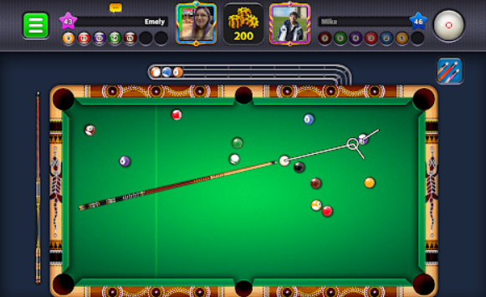

1. **Write about how to play the game?**

The main idea, rules, and everything in the game is a simulation of the game in the real world, as the game is divided into two parts:

The first section, the players must pay attention to the type of balls of each of them, and each player can hit his balls by hitting another ball, which is considered the correction to hit the target in order and put them in the holes before the other opponent.

As for the second game: the players have the same balls, numbered from one to nine, and the players must enter the balls alternately and win in favor of whoever enters the eighth ball

1. **What are the Game Rules, including winning and losing events?**

In both games common ground rules:

* The player must hit the balls with the white cue ball.
* If the player does not hit any ball, the turn will pass to the other player directly.

Special first game rules:

* Do not touch the balls of the second opponent or the turn will pass to him openly.
* Only your balls enter.
* Don't touch or don't get the black ball into the hole, you lose the whole game.
* Put all your balls into the holes and then enter the black ball to win.

the second game:

* Don't touch the black ball and enter it with the holes, you will lose the whole game.
* Insert the balls in the order written on it

1. **Write an algorithm for loading and saving the player’s data. Start, for example, start from “when the user clicks ctrl+s ”. (Note! The data and their types must be clearly specified)**

**This is just an example:**

The easiest way to create a saving loading system is to use an INI file. These are simply text files that contain the variables saved.

**Save the game:**

ini_open("saveData.ini");

ini_write_real("Variables", "score", score); //The first value is a header for that section, the second value is the label for your variable in the INI file, and the third value is the actual variable

ini_write_string("Variables","string",string); //This is how you save strings

ini_close(); //Remember to close the INI or you'll have a memory leak

**load the game:**

ini_open("saveData.ini");

score = ini_read_real("Variables","score",0); //The third value here will set the score variable if there is no save file

string = ini_read_string("Variables","string","Hello world"); //This is a string instead of a number

ini_close();

1. **Explain if there is an economic system, spawning process, or use of Randomness in the game?**

The economic system within the game is somewhat difficult and may lead the player to boredom and concern for normal play only.

The system here consists of coins that are earned at every victory that the player wins or when he passes a new stage that he is provided with coins. These coins are used for purchases from the in-store for holdings such as new ball colors, new and innovative shape, structure, and colors of the table, in addition to various shapes of playing sticks, but all of these Collectibles are very expensive compared to the simple coins that are collected